**CAP 447: DATA WAREHOUSING AND DATA MINING - LABORATORY**

**PRACTICAL-C.A-3**

**ST_NAME: - EKHLAKH AHMAD**

**REG NO.: - 12209166**

**ROLL NO.: - RD2215B67**

**SECTION: - D2215**

**GROUP: - B**

**Q. import data and perform some task and operation**

1. **Rename**
2. **Replace**
3. **Sort**
4. **Adding Column**
5. **Filter**

**Process: -**

* Open Rapid Miner software.
* Click on Turbo Prep.
* 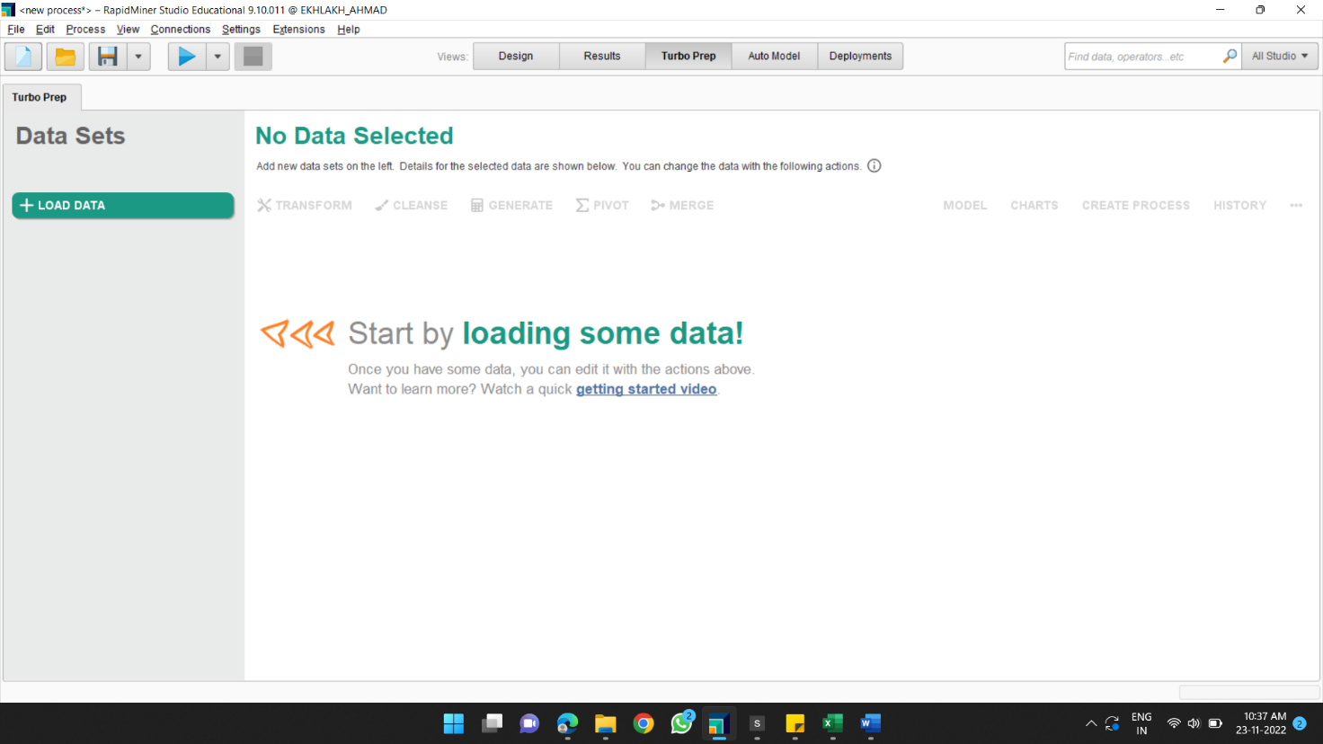Load data.
* Import data.
* 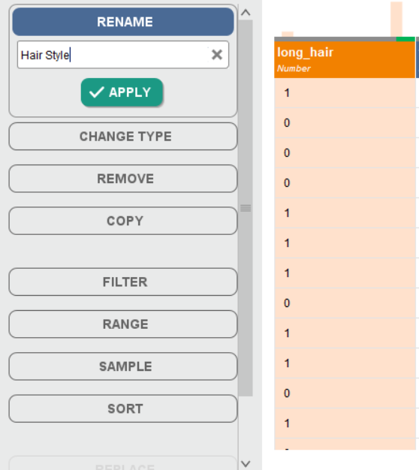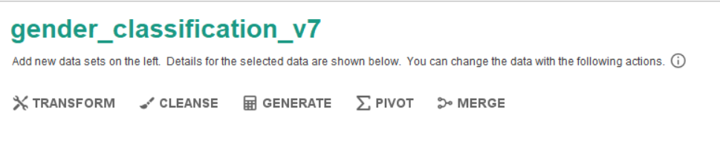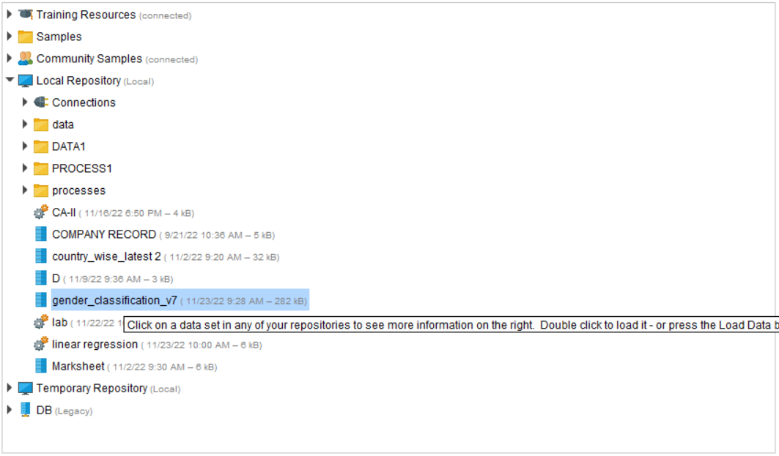click on Transform.

1. **Rename**

Long_hair to Hair Style

1. 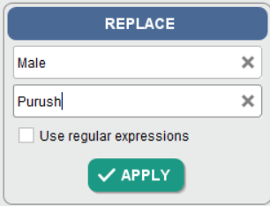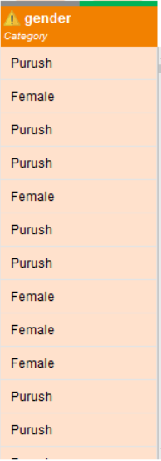**Replace.**
2. 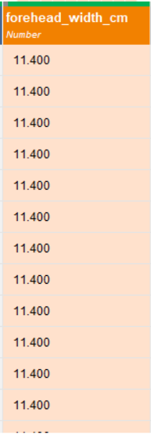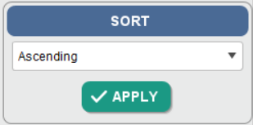**Sort.**
3. 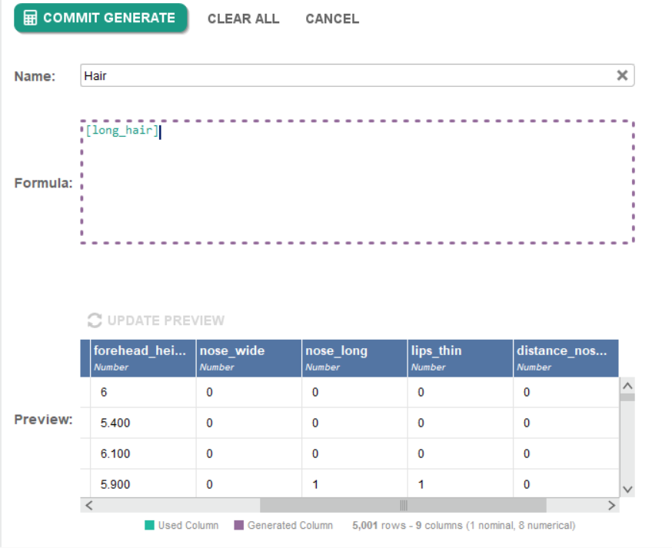**Adding Column.**
4. 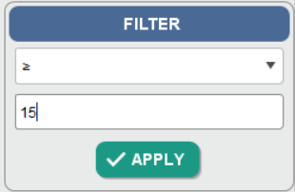**Filter**

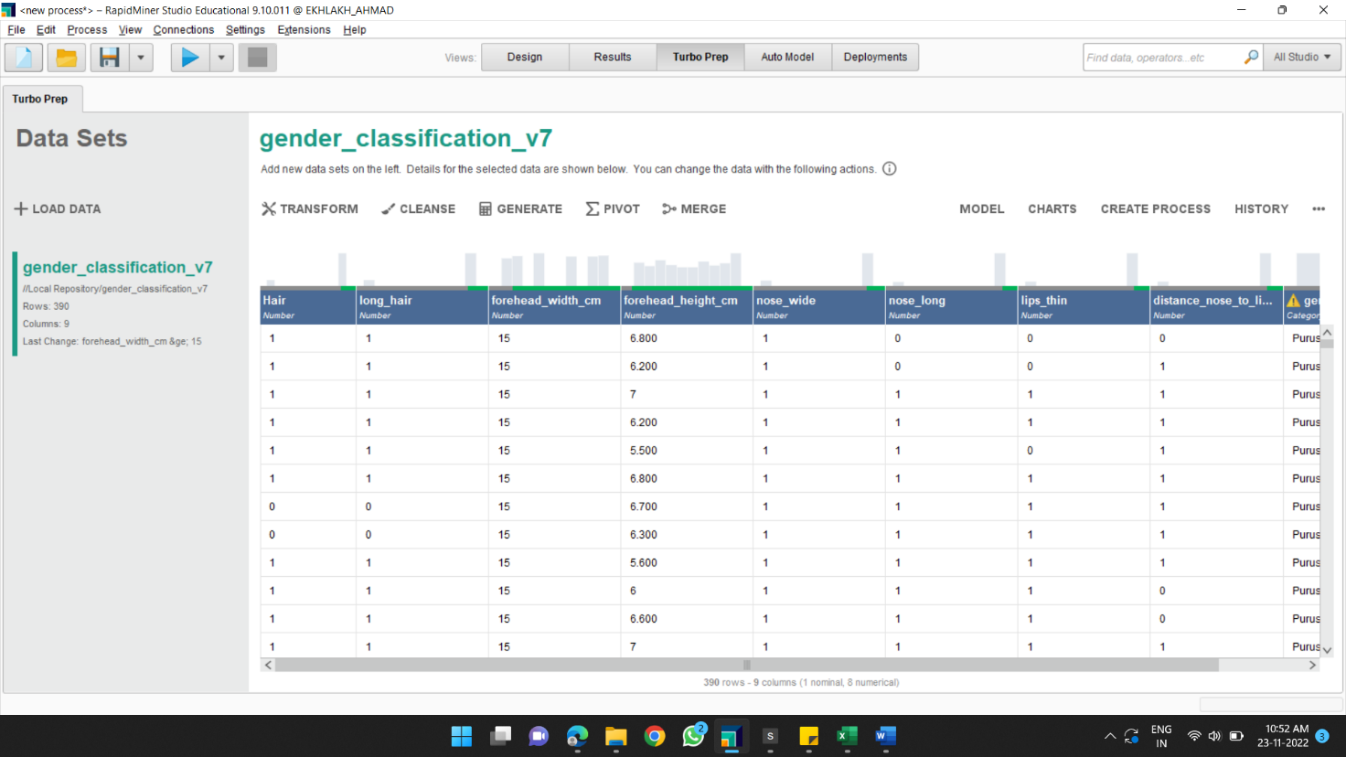

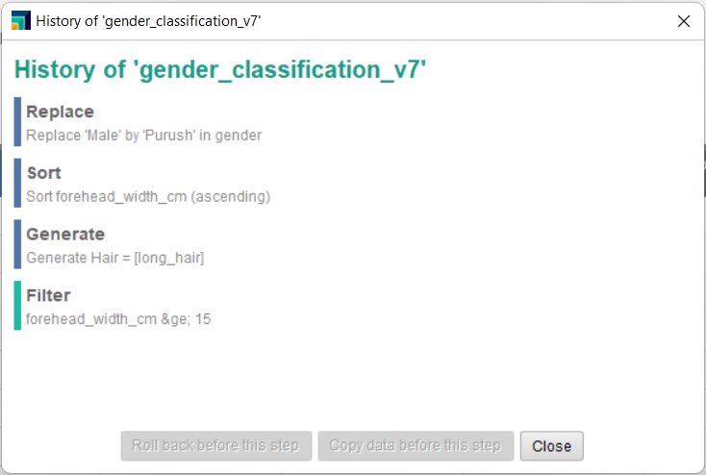**History**